TOPOLOGY
Definition: Structure or layout of the network is known as Topology.
- Topology are
- Physical Topology: Explain the actual physical layout.
- Logical Topology: Explain the logical flow of data through the network
- There are following types of topology
- Mesh
- Bus
- Star
- Ring
- Hybrid
MESH TOPOLOGY
- Every device has a dedicated point-to-point link to every other device.
- To find the number of physical link in a mesh network with n nodes, we need n(n-1)/2 link.
- To support n(n-1)/2 link , every device need n(n-1)/2 i/o port.
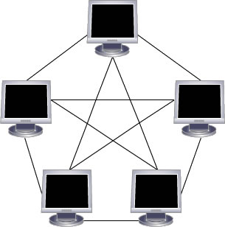
- Data sent using a mesh topology can take several different paths to its destination.
Advantages
- Each connection can carry its own data load, so eliminating traffic problem.
- If one link become unusable, it doesn’t impact the entire system.
- Provide more security because every message travel along dedicated line so only recipient sees it.
- Easy Fault Identification and isolation.
Disadvantages
- Costly. Require more cable and I/O ports. Because if we want to network 5 pc we need 10 cables with each pc require 9 NIC to connect with each other.
- Installation and reconnection are difficult. Because of more cable or web of cables it is difficult to reconnection if any error occurs.
- Limited to small network.
STAR TOPOLOGY
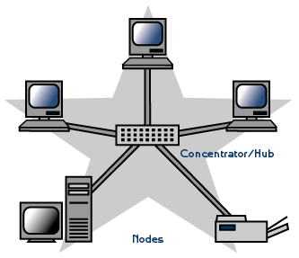
- In Star topology, Devices are not connected directly but each device is connected to a central device called hub through cable.
- Don’t allow direct traffic.
- The hub act as a central controller and if device want to send data to another device it boost up the message and send the message to intended device.
- So Data passes through hub before reaching destination.
- It commonly uses twisted pair cable, however fiber optic or coaxial cable can also be used.
Advantages
- Easy to install and wire.
- Network is not disrupted even if node fail or it removes from the network.
- Fault detection and removal of faulty parts easier.
Disadvantages
- Require more cable compare to bus and ring topology.
- If central device fail, node attached to it are disabled to communicate.
- Cost of central device (hub) makes the network expensive as compared to bus and ring topology.
BUS TOPOLOGY
- It is multipoint topology because all device are connected on single cable.
- It is also known as Daisy Chained Topology because connected one right after the other.
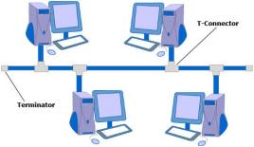
- All devices are connected to a common cable called trunk.
- One long cable work as backbone to link all other device.
- Nodes are connected to bus cable by drop lines and cables.
- Drop line is connection between device and main cable .
- Tap is a connector that attached to the main cable to its metallic core.
- Limited number of tap used because the signal becomes weak while travelling through wire and loose their energy in form of heat.
- Maximum segment length of cable is 200 m
- Maximum of 30 devices per segment.
How It works?
- A signal from the source is broadcasted.
- It travels to all workstations connected to bus cable.
- Only the intended recipient, whose MAC address or IP address matches, accepts it.
- If the MAC /IP address of machine doesn’t match with the intended address, machine discards the signal.
Advantages
- Ease of installation because backbone cable laid along the most efficient path.
- Require Less cabling than star and mesh topology.
Disadvantages
- Difficult reconnection and fault isolation.
- Difficult to add new device.
- Break in a cable stop all transmission.
- Limited cable length and number of station.
- Maintenance cost may be higher.
- Performance degrade as addition computer are added.
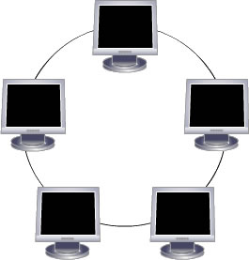
- Does not cope with heavy traffic rate.
RING TOPOLOGY
- Each device connect to exactly two other nodes.
- Single continuous path for signal through each node.
- All devices have equal access to media.
- Ring networks operate like bus networks with the exception of a terminating computer.
- In this configuration, the computers in the ring link to a main communication cable.
- The network receives information via a "token" containing information requested by one or more computers on the network.
- The token passes around the ring until the requesting computer(s) have received the data.
- The token uses a packet of information that serves as an address for the computer that requested the information.
- The computer then "empties" the token, which continues to travel the ring until another computer requests information to be put into the token.
Advantages
- Easy to install and reconfigure. Because each device is linked to only its immediate neighbours
- Fault isolation is simplified.
- Perform better than bus topology under heavy traffic load.
- Does not require central device.
Disadvantages
- Unidirectional traffic means data should be transferred only in one direction.
- Break in a cable disable whole network.
- Bandwidth is shared on all link.
- Moving, adding and changing the devices can affect the network.
HYBRID TOPOLOGY
- It is two different types of topologies which is a mixture of two or more topologies.
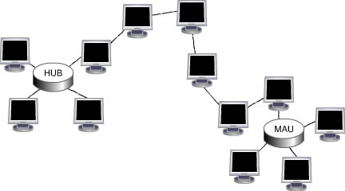
- For example if in an office in one department ring topology is used and in another star topology is used, connecting these topologies will result in Hybrid Topology (ring topology and star topology).
Advantages
- Used for creating larger networks
- Handles large volume of traffic
- Fault detection is easy
Disadvantages
- Installation and configuration is difficult
- More expensive than other topologies
- More cabling is required
Que:Which factor are consider to select the topology?
- Following factors are consider when selecting the topology.
- Budget
- Number of User
- Reliability
- Scalability
- Bandwidth capacity
- Ease of installation
- Ease of troubleshooting

LOGICAL TOPOLOGY [In exam explain topology in detail so it make 7 marks content]
- The logical topology defines how the data should transfer from one device to the next without regard to the physical interconnection of the devices.
- Also known as “Signal Topology”
- This topology is limited to ‘network protocols’ & define or describe how data is moved across the network.
- Each network also has a logical topology that may or may not be the same as its physical topology.
- Two of the most common logical topologies are:
Bus topology:
- Ethernet uses the logical bus topology to transfer data.
- Under a bus topology a node broadcasts the data to the entire network.
- All other nodes on the network hear the data and check if the data is intended for them.
Ring topology:
- In this topology, only one node can be allowed to transfer the data in a network at a given time.
- This mechanism is achieved by token (the node having token only can transmit the data in a network) and hence the collision can be avoided in a network.
PHYSICAL TOPOLOGY
- The way that the workstations are connected to the network through the actual cables that transmit data (the physical structure of the network) is called the physical topology.
- The method employed to connect the physical devices on the network with the cables, and the type of cabling used, all constitute the physical topology.
- Types of physical topologies include:
- Star Topology: A topology with a single access point or a switch at the center of the topology; all the other nodes are connected directly to this point.
- Tree (Extended Star) Topology: A combination of both the star and the linear bus topologies. This topology has multiple access points connected to the linear bus, while the nodes are connected to their respective access points.

